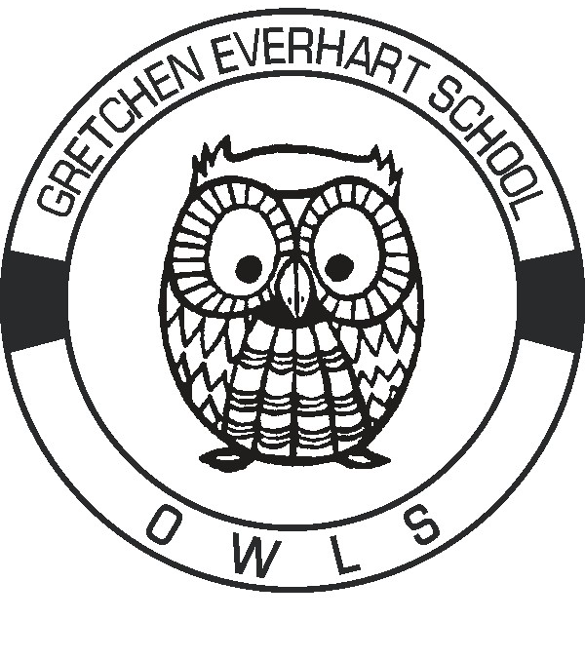

Safety Considerations at Gretchen Everhart School

2021-2022 School Year

This year we will continue to have some challenges as we all stay safe and well despite the pandemic. Here is what we have in place to protect us all:

Everhart will use proactive measures to help safeguard the health and safety of our students and staff that follow local health guidelines:

* + Students who are sick will go to a designated isolation area away from others until picked up
  + Students remain home for 48 hours fever free before returning to school
  + Everyone will adhere to hygiene and social distancing routines as much as possible
  + Students and staff will maintain six feet of distance whenever possible
  + Classroom arrangements will allow for physical distancing
  + Hand sanitizer and hand washing will be done throughout the day
  + Staff who are not vaccinated will wear masks and optional mask wearing for others
  + Visitors will be limited and will be asked to stay outside
  + Students and staff will remain with their classroom group and will avoid other groups
  + Meetings will be often have an online option
  + No large group gatherings
  + Limited time in common areas / hallways
  + Cleaning protocols will be used on high touch surfaces throughout the day
  + Classrooms will each have a cleaning kit of materials
  + Teachers will have a “used” box for items that have been used
  + Students will not share items among themselves
  + Parents/Caregivers will be asked to wait outside until they are assisted by staff
  + Limit items coming to school and sanitize materials, backpacks and supplies each day
  + The Health Department will be used to contact trace and make decisions about testing
  + There will be no field trips, CBI trips or group gatherings during the first nine weeks